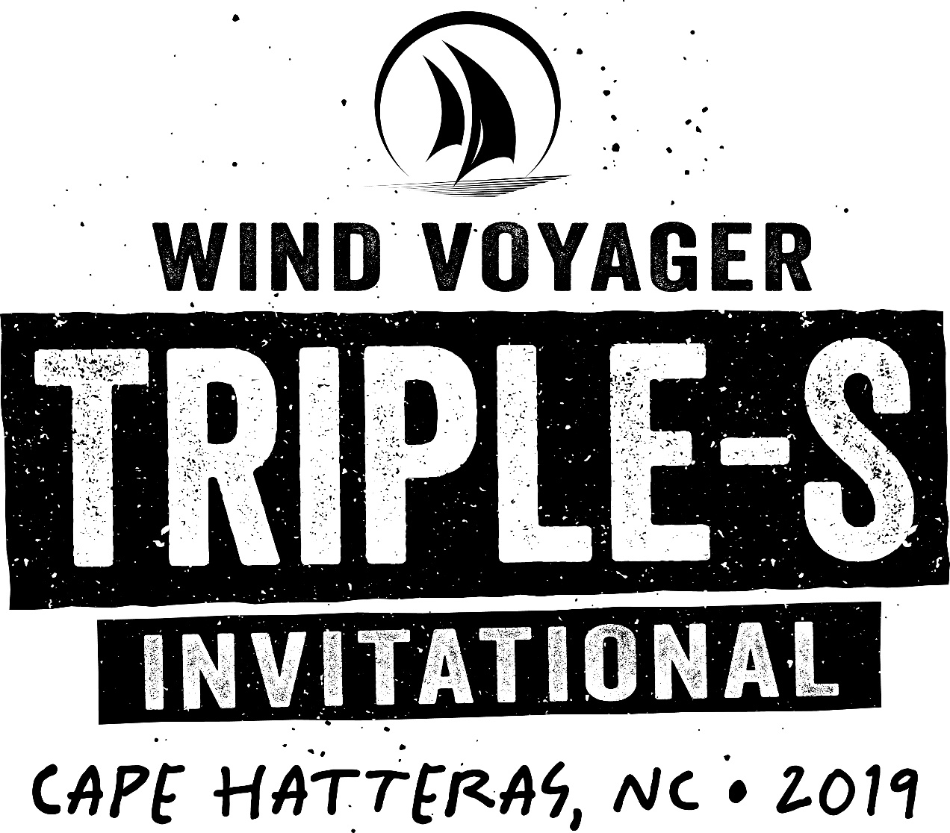

2019 Wind Voyager Triple-S Invitational
OFFICIAL COMPETITION INSTRUCTIONS

2019 Wind Voyager Triple-S Invitational
OFFICIAL COMPETITION INSTRUCTIONS

FORMAT
Wind Voyager Triple-S Open — Men’s & Women’s Divisions
Wind Voyager Triple-S Invitational — Men’s & Women’s Divisions

- The Wind Voyager Triple-S Open*

Riders: Limited to 32 riders, which will be divided into heats.
Format: The REAL Slider Park will be set up in front of REAL Watersports, divided into three areas consisting of up to two features each. One heat of riders will be on the water at a time. Each heat of riders will focus on one feature before moving on to the next feature.
Each competitor will hit each feature three times, with their top score for each feature counting towards their overall score for the round. Competitors are allowed one pass per feature. This does not count as one of your three hits for the feature. If a competitor chooses to pass on a feature they must clear the course and immediately return to the end of the line. Once a competitor has used their pass they must hit the feature or a score of zero will be posted for the that hit.
Event Scoring: The sum of a competitor’s top scores from each feature will be his or her overall score. A result can be reached by scoring as few as two park features if conditions warrant. In optimal conditions, we will use all park features. In the event of no wind, a result can be reached by wakeboarding the features.
Stakes: The top female rider and top male rider advance into the 2019 Wind Voyager Triple-S Invitational. To compete in the 2019 Wind Voyager Triple-S Invitational a competitor must be able to competently ride all features in the REAL Slider Park.

2. The Wind Voyager Triple-S Invitational*

ROUND 1
Riders: Men will be seeded into three heats of 8, and Women will be seeded into one heat of 10
Format: The REAL Slider Park will be divided into three areas consisting of two features each. One heat of riders will be on the water at a time. Each heat of riders will focus on one feature before moving on to the next feature.
Each competitor will hit each feature three times, with their top score for each feature counting towards their overall score for the round. Competitors are allowed one pass per feature. This does not count as one of your three hits for the feature. If a competitor chooses to pass on a feature they must clear the course and immediately return to the end of the line. If a rider has used their pass and fails to hit the feature a score of zero will be posted for the that hit.
The top 3 competitors from each heat will advance to Round 3, 4th-6th in the Men’s Heats and 4th-8th in the Women’s Heat will advance to Round 2. Scores from this round can be used for a final score.

ROUND 2
Riders: Men will be re-seeded into one heat of 9, and Women will be re-seeded into one heat of 5. Round 2 seeding will be determined by Round 1 results.
Format: Round 2 will be run weather and time permitting. If Round 2 is not run, the top 12 Men and the top 5 Women from Round 1 will advance directly into Round 3. The REAL Slider Park will be divided into three areas consisting of: two features, two features, and one feature. One heat of riders will be on the water at a time. Each heat of riders will focus on one feature before moving on to the next feature.
Each competitor will hit each feature three times, with their top score for each feature counting towards their overall score for the round. Competitors are allowed one pass per feature. This does not count as one of your three hits for the feature. If a competitor chooses to pass on a feature they must clear the course and immediately return to the end of the line. If a rider has used their pass and fails to hit the feature a score of zero will be posted for the that hit.

ROUND 3
Riders: Men will be re-seeded into one heat of 12, and Women will be re-seeded into one heat of 5. Round 3 seeding will be determined by Round 1 and Round 2 results.
Format: The REAL Slider Park will be divided into three areas consisting of up to two features. One heat of riders will be on the water at a time. Riders will focus on one feature before moving on to the next feature.
Each competitor will hit each feature three times, with their top score for each feature counting towards their overall score for the round. Competitors are allowed one pass per feature. This does not count as one of your three hits for the feature. If a competitor chooses to pass on a feature they must clear the course and immediately return to the end of the line. If a rider has used their pass and fails to hit the feature a score of zero will be posted for the that hit.

Men’s Prize Purse
1. $12,000
2. $7,500
3. $5,000
4. $3,000
5. $2,000
6. $1,500
7. $1,200
8. $1,000
9. $800
10. $600
11. $500
12. $400
Women’s Prize Purse
1. $12,000
2. $7,500
3. $5,000
4. $3,000
5. $2,000

Wind Voyager Triple-S Invitational Challenge Series:
720 Challenge: $2,880** (first woman to land a 720 handle pass off kicker in an Invitational heat)
1080 Challenge: $4,320** (first person to land a 1080 handle pass off kicker in an Invitational heat)

If more than one competitor completes the challenge on the same run, the prize purse will be split equally amongst the winning competitors. Entire rotation must be completed after leaving the kicker, without pre-spinning.

Additional Awards:
Best Wipeout: Prize Pack
Slickstyle Attitude: Prize Pack

*Organizers reserve the right to change format, heat times, and number of runs through park based on conditions.
**720/1080 Challenges were not completed in 2018, therefore prize money was carried over to 2019 challenge

SEEDING
Invitational Seeding: Riders will be seeded into heats based on results from last year’s competition, invitations, Wild Card standings and Open results. Re-seeding in Round 2 and Round 3 is based on heat results from the previous round(s).

SCORING & JUDGING CRITERIA

The entire event will be judged using the same criteria, and scores will be calculated consistently using the same criteria throughout the event as well.

SCORING
For all rounds, a rider’s highest scoring trick on each of the six features will go towards their Overall Score for the round. With scores ranging from 0 to 10 points for kickers and rails, a rider can score a max of 60 points for any round. All Overall Scores will therefore be calculated as follows:

HOW ALL SCORES WILL BE CALCULATED
KOA Kicker High Score | 0-10 points
Wind Voyager Superkicker High Score | 0-10 points
Core Reverse Rainbow High Score | 0-10 points
Liquid Force Rooftop Rail High Score | 0-10 points
Phocus A-Frame High Score | 0-10 points
Duotone Mega Feature | 0-10 Points
OVERALL ROUND SCORE  (sum of all scores) | 0-60 points

If a rider entirely fails to hit a feature or forfeits their opportunity to do so in any round, a score of 0 will be posted for that feature.

In the event of a tie, judges will employ DRIVE. If two riders have the exact score, their performance will be further evaluated according to the criteria of DRIVE: Difficulty, Risk, Intensity, Variation, and Execution. One rider or another will win each of these five categories, so whoever wins three or more will be declared the winner of the tie.

Overall Scores for each round will be used to determine advancement, seeding, and/or results.

JUDGING CRITERIA
All competitors will be judged according to The Wind Voyager Triple-S Standards. The judges will be scoring based on trick hierarchy, difficulty, risk, intensity, variation and execution.

Kickers —In general, there are two main types of tricks: spins and inverts. Spins fall into four base tricks: heelside frontside, heelside backside, toeside frontside, and toeside backside. Inverts fall into six base tricks — three heelside, three toeside. Heelside inverts include: front flip, back roll, tantrum. Toeside inverts include: front flip, back roll, front roll. While not considered full inverts, there are four other base tricks that come from the raley: heelside raley, heelside s-bend, toeside raley, and toeside s-bend.

All of the possible tricks on kickers stem from these four base spins, six base inverts, and four base raleys.

Rails —In general, there are five types of base score, two types of entry, and two types of exit, along with several additions and deductions. The five base scores include: 50-50, backside boardslide, backside lipslide, frontside boardslide, and frontside lipslide. As outlined in the Wind Voyager Triple-S Standards, different rails are graded at varying degrees of difficulty, and therefore have differing point values for the five base scores. The two types of entry and exit are frontside spin and backside spin. Additions include presses, spins, transfers, etc.

Additions and Deductions —In general, this will include things such as grabs, presses, butt checks, poor form, zeeching, if a kite is too high, etc.

Style Matters!
Clean, powerful and stylish riding has always been the foundation of the Wind Voyager Triple-S Invitational and is therefore an integral part of how riding is judged. Riding that exhibits style will be rewarded. In short, how tricks are done — style, or lack thereof — will be factored into the score for each rail and kicker hit.

COMPETITION AREA & SIGNALS

PARK SETUP
The REAL Slider Park will be divided into three areas consisting of up to two features each. Organizers reserve the right to assign groups and switch features based on conditions. The angle of each feature will be set and confirmed by a selection of Triple-S competitors. Angle of each feature will only be changed in the event of a radical change in wind direction or speed.

COMPETITION AREA
The competition area is only accessible by Wind Voyager Triple-S Invitational and Open riders that are being scored, unless it’s an official Media Jam Session, which is open to media and Wind Voyager Invitational riders only. If need be, organizers will remove people from the competition area to keep it clear for competitors.

PARK RIDING RULES
During all rounds, riders are required to yield right of way to the rider on approach. This means that after a rider hits a feature and is heading back upwind, it is his or her responsibility to not get in the way of riders who are lined up and on approach to a feature.

The Wind Voyager Triple-S Invitational promotes good sportsmanship between competitors. Event organizers reserve the right to remove a rider from a heat if they are repeatedly not mindful of other riders on approach or are intentionally preventing fellow competitors from hitting features. Riders in violation of this policy will be given one official warning by the Head Judge, and upon a second unsportsmanlike act, will be removed from the heat and their heat score will be reduced 20 percent.

FLAG & HORN SIGNALS
Organizers will use flags as the primary means of differentiating heats in progress and warmup periods. Horn blasts will accompany each flag change, but in the event of horn failure, flag signals will be primary:

Green Flag - Competition in progress
Black Flag - Warmup period
No Flag - Competition on hold

GEAR & GEAR CHANGES
Riders can change or replace equipment at their discretion, but the competition will not stop. It is the rider's responsibility to be ready to take their run when it is their turn. If a rider is not present or not ready to take their run, they will receive 0 for that attempt.
ADDITIONAL INFORMATION

CONTESTABLE CONDITIONS
Event organizers do not control the wind and weather conditions. In the event of sub-par conditions, the competition will be put on hold until conditions improve or stabilize to the point where the event can resume. In the event the contest cannot be completed, the men’s and women’s prize purses will be evenly distributed among the remaining competitors.

COMPETITORS DRESS CODE
Competitors must wear the official 2019 Wind Voyager Triple-S Invitational water shirt or tank top during all competition heats and official media freeride sessions.

EVENT STATUS UPDATES
It is a rider’s responsibility to regularly monitor TripleSinvitational.com as the sole source of information for the event status. On TripleSinvitational.com, riders can always find the status of the event, including the time and location of the next riders meeting or session. Riders should not make inquiries about event status to REAL employees, event staff, other competitors or anyone else, and should instead use TripleSinvitational.com as the sole source of event information.

DAILY MEDIA
All riders and their sponsors will be given open access to a daily pool of action shots of Invitational athletes and lifestyle photos of the event. All parties will be free and encouraged to use the shots to promote themselves and the event on social media, websites, etc. The photos will be watermarked with the official event logo and photographer credit. This watermark must remain on the photo for all subsequent use.

EVENT HASHTAGS
For all social media postings please use the following hashtags.

Instagram
#WindVoyagerTripleS
@REALwatersports
#REALwatersports

Facebook
@REAL Watersports
@Triple-S Invitational
SCHEDULE OF EVENTS
Rider registration and autograph sessions are mandatory. Please be prompt.

Friday, May 31st
9am-10am: 2019 Wind Voyager Triple-S Open Registration
6pm-10pm: Dub Island Sound System
Saturday, June 1st
2pm-4pm: 2019 Wind Voyager Triple-S Invited Rider Registration
6pm: Wind Voyager Triple-S Invitational Welcome Dinner*
7pm: Autograph Session
8pm-12 Midnight: Mix Master Mike of the Beastie Boys & The Dubplates with Special Guests DJ Qbert and Future Fambo**
Sunday, June 2nd
9am: Riders Meeting @ REAL
8pm-11pm: DJ No Philter
Monday, June 3rd
8pm-11pm: Mystic Vibrations
Tuesday, June 4th
8pm-11pm: “Send It” The Movie Premiere Party**
Wednesday, June 5th
8pm-11pm: Aaron Hadlow Twenty Premiere Party and American Pinup
Thursday, June 6th
8pm-11pm: Sunset Swim Charity Fashion Show (tickets required)
Friday, June 7th
6pm: Wind Voyager Triple-S Invitational Awards Dinner**
7pm: Autograph Session
8pm: Awards Ceremony
8pm-12 Midnight: The Roots & The Dubplates with Special Guests DJ Qbert and Future Fambo**

*Included in the Wind Voyager Triple-S Open and Invited rider registration
** Included in the Wind Voyager Triple-S Invited rider registration

© 2019 Wind Voyager Triple-S Invitational

This document may not be used in part or full without the express written consent of the Triple-S Steering Committee.

